SEC Form 4

FORM 4

Check this box if no longer subject to Section 16. Form 4 or Form 5 obligations may continue. See Instruction 1(b).

UNITED STATES SECURITIES AND EXCHANGE COMMISSION
Washington, D.C. 20549
 |  | OMB APPROVAL
STATEMENT OF CHANGES IN BENEFICIAL OWNERSHIP
 |  | OMB Number: | 3235-0287
 |  | Estimated average burden
Filed pursuant to Section 16(a) of the Securities Exchange Act of 1934 |  | hours per response: | 0.5
or Section 30(h) of the Investment Company Act of 1940
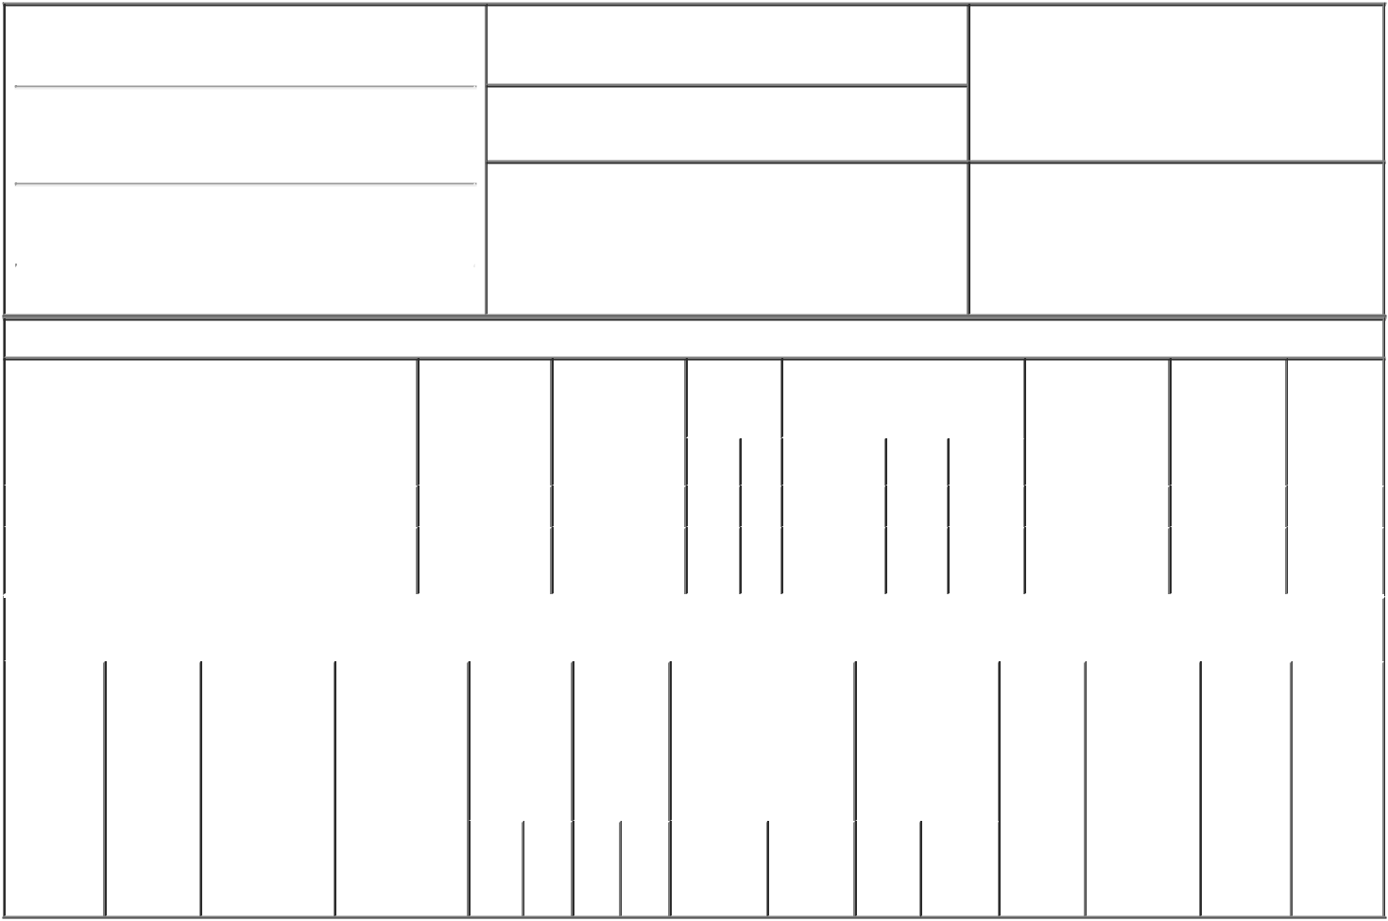

1. Name and Address of Reporting Person*
BOGGS PAULA

(Last) (First) (Middle)

75 NETWORK DRIVE

2. Issuer Name and Ticker or Trading Symbol
AVID TECHNOLOGY, INC. [ AVID ]

3. Date of Earliest Transaction (Month/Day/Year)

05/18/2022

- Relationship of Reporting Person(s) to Issuer (Check all applicable)
X Director 10% Owner

Officer (give title Other (specify

below) below)

(Street)
 | BURLINGTON | MA | 01803
 | (City) | (State) | (Zip)

4. If Amendment, Date of Original Filed (Month/Day/Year) 6. Individual or Joint/Group Filing (Check Applicable

Line)
X Form filed by One Reporting Person

Form filed by More than One Reporting

Person

Table I - Non-Derivative Securities Acquired, Disposed of, or Beneficially Owned

 | 1. Title of Security (Instr. 3) |  |  | 2. Transaction |  | 2A. Deemed | 3. |  | 4. Securities Acquired (A) or |  |  |  |  | 5. Amount of |  | 6. Ownership | 7. Nature of
 |  |  |  | Date |  | Execution Date, |  | Transaction | Disposed Of (D) (Instr. 3, 4 and 5) Securities |  |  |  |  |  |  | Form: Direct | Indirect
 |  |  |  | (Month/Day/Year) |  | if any |  | Code (Instr. |  |  |  |  |  | Beneficially |  | (D) or Indirect | Beneficial
 |  |  |  |  |  | (Month/Day/Year) | 8) |  |  |  |  |  |  | Owned Following |  | (I) (Instr. 4) | Ownership
 |  |  |  |  |  |  |  |  |  |  |  |  |  | Reported |  |  | (Instr. 4)
 |  |  |  |  |  |  |  | Code V | Amount |  | (A) or | Price |  | Transaction(s)
 |  |  |  |  |  |  |  |  |  |  | (D) |  |  | (Instr. 3 and 4)
 | Common Stock |  |  | 05/18/2022 |  |  |  | A | 6,242⁽¹⁾ |  | A | $0 | 113,231 |  |  | D
 | Common Stock |  |  |  |  |  |  |  |  |  |  |  | 16,500 |  |  | I | Boggs
 |  |  |  |  |  |  |  |  |  |  |  |  |  |  |  |  | LLC⁽²⁾
 |  |  | Table II - Derivative Securities Acquired, Disposed of, or Beneficially Owned
 |  |  |  | (e.g., puts, calls, warrants, options, convertible securities)
 | 1. Title of | 2. | 3. Transaction | 3A. Deemed | 4. | 5. Number | 6. Date Exercisable and |  |  | 7. Title and |  |  | 8. Price of |  | 9. Number of 10. |  | 11. Nature
 | Derivative | Conversion | Date | Execution Date, | Transaction | of | Expiration Date |  |  | Amount of |  |  | Derivative |  | derivative | Ownership | of Indirect
 | Security | or Exercise | (Month/Day/Year) | if any | Code (Instr. | Derivative | (Month/Day/Year) |  |  | Securities |  |  | Security |  | Securities | Form: | Beneficial
 | (Instr. 3) | Price of |  | (Month/Day/Year) | 8) | Securities |  |  |  | Underlying |  |  | (Instr. 5) |  | Beneficially | Direct (D) | Ownership
 |  | Derivative |  |  |  | Acquired |  |  |  | Derivative |  |  |  |  | Owned | or Indirect | (Instr. 4)
 |  | Security |  |  |  | (A) or |  |  |  | Security (Instr. 3 |  |  |  |  | Following | (I) (Instr. 4)
 |  |  |  |  |  | Disposed |  |  |  | and 4) |  |  |  |  | Reported
 |  |  |  |  |  | of (D) (Instr. |  |  |  |  |  |  |  |  | Transaction(s)
 |  |  |  |  |  | 3, 4 and 5) |  |  |  |  |  |  |  |  | (Instr. 4)
 |  |  |  |  |  |  |  |  |  |  | Amount
 |  |  |  |  |  |  |  |  |  |  | or
 |  |  |  |  |  |  |  |  |  |  | Number
 |  |  |  |  |  |  | Date |  | Expiration |  | of
 |  |  |  |  | Code V | (A) (D) | Exercisable |  | Date | Title | Shares

Explanation of Responses:

- Represents an award of restricted stock units ("RSUs") that will vest in full on the earlier of the date of the Company's 2023 Annual Meeting or May 18, 2023. Each RSU represents the contingent right to receive one share of the Issuer's common stock.

- The reporting person is the majority owner of Boggs LLC.

Remarks:

/s/ Alessandra Melloni as

Attorney-in-Fact for Paula E. 05/19/2022
Boggs

** Signature of Reporting Person Date

Reminder: Report on a separate line for each class of securities beneficially owned directly or indirectly.

* If the form is filed by more than one reporting person, see Instruction 4 (b)(v).

- Intentional misstatements or omissions of facts constitute Federal Criminal Violations See 18 U.S.C. 1001 and 15 U.S.C. 78ff(a). Note: File three copies of this Form, one of which must be manually signed. If space is insufficient, see Instruction 6 for procedure.
Persons who respond to the collection of information contained in this form are not required to respond unless the form displays a currently valid OMB Number.

LIMITED POWER OF ATTORNEY

FOR SECTION 16 REPORTING OBLIGATIONS

Know all by these presents, that the undersigned hereby makes, constitutes and appoints each of Jason A. Duva, Alessandra Melloni and Gregory McIntosh, signing singly and each acting individually,

as the undersigned's true and lawful attorney-in-fact with full power and authority as hereinafter described to:

- execute for and on behalf of the undersigned, in the undersigned's capacity as an officer and/or director of Avid Technology, Inc. (the "Company"), Forms 3, 4, and 5 (including any amendments thereto) in accordance with Section 16(a) of the Securities Exchange Act of 1934 and the rules thereunder (the "Exchange Act");

- do and perform any and all acts for and on behalf of the undersigned which may be necessary or desirable to prepare, complete and execute any such Form 3, 4, or 5, prepare, complete and execute any amendment or amendments thereto, and timely deliver and file such form with the United States Securities and Exchange Commission and any stock exchange or similar authority;

- seek or obtain, as the undersigned's representative and on the undersigned's behalf, information regarding transactions in the Company's securities from any third party, including brokers, employee benefit plan administrators and trustees, and the undersigned hereby authorizes any such person to release any such information to such attorney-in-fact and approves and ratifies any such release of information; and

- take any other action of any type whatsoever in connection with the foregoing which, in

the opinion of such attorney-in-fact, may be of benefit to, in the best interest of, or legally required by, the undersigned, it being understood that the documents executed by such attorney-in-fact on behalf of the undersigned pursuant to this Power of Attorney shall be in such form and shall contain such terms and conditions as such attorney-in-fact may approve in such attorney-in-fact's discretion.

The undersigned hereby grants to each such attorney-in-fact full power and authority to do and perform any and every act and thing whatsoever requisite, necessary, or proper to be done in the exercise of any of the rights and powers herein granted, as fully to all intents and purposes as the undersigned might or could do if personally present, with full power of substitution or revocation, hereby ratifying and confirming all that such attorney-in-fact, or such attorney-in-fact's substitute or substitutes, shall lawfully do or cause to be done by virtue of this power of attorney and the rights and powers herein granted. The undersigned acknowledges that the foregoing attorneys-in-fact, in serving in such capacity at the request

of the undersigned, are not assuming nor relieving, nor is the Company assuming nor relieving, any of the undersigned's responsibilities to comply with Section 16 of the Exchange Act. The undersigned acknowledges that neither the Company nor the foregoing attorneys-in-fact assume (i) any liability for the undersigned's responsibility to comply with the requirements of the Exchange Act, (ii) any liability of the undersigned for any failure to comply with such requirements, or (iii) any obligation or liability of the undersigned for profit disgorgement under Section 16(b) of the Exchange Act.

This Power of Attorney shall remain in full force and effect until the undersigned is no longer required to file Forms 3, 4, and 5 with respect to the undersigned's holdings of and transactions in securities issued by the Company, unless earlier revoked by the undersigned in a signed writing delivered to the foregoing attorneys-in-fact.

IN WITNESS WHEREOF, the undersigned has caused this Power of Attorney to be executed as of this 2nd day of May, 2019.

/s/ Paula E. Boggs

